# Cross Sections and Correlation Diagrams

In an edit session, draw a cross section line so that the data goes into the CartographicLines layer

If you are working in a versioned database, add cross section and correlation of map units dataset to your project and create cross section.

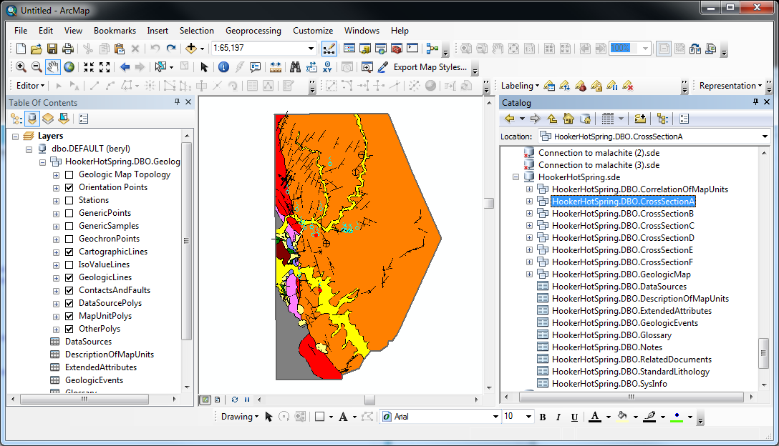

Drag and drop dataset into your Map Document and create lines and polys as you do with the main geologic map. Refer to Matching Colors help doc for how to match polygon fill colors to geologic map units

Put cross section line in this feature layer